Swapping of 2 numbers:

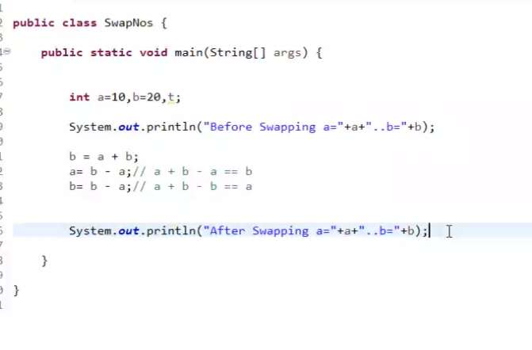
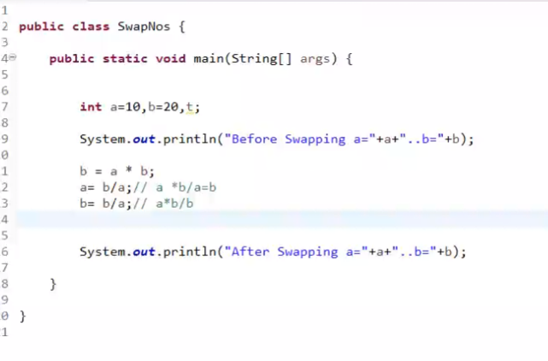

public class SwapNos {

public static void main(String[] args) {

int a=10,b=20,t;

System.out.println("Before Swapping a="+a+"..b="+b);

//a = a + b;
//b = a - b;
//a = a- b;

b = a * b;
a= b/a;// a *b/a=b
b= b/a;// a*b/b

// 90/0

System.out.println("After Swapping a="+a+"..b="+b);

}

}

// Finding biggest and smallest numbers:

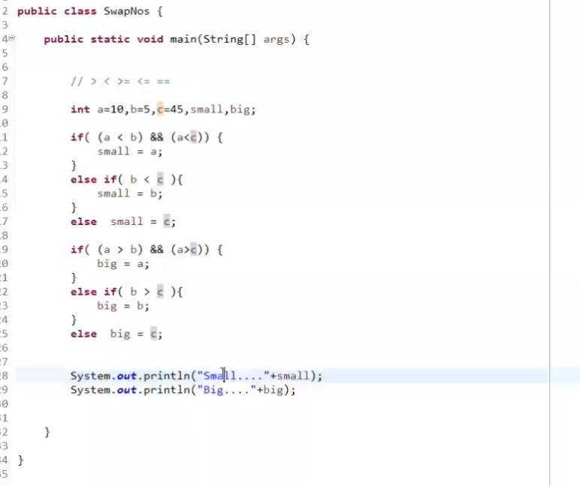
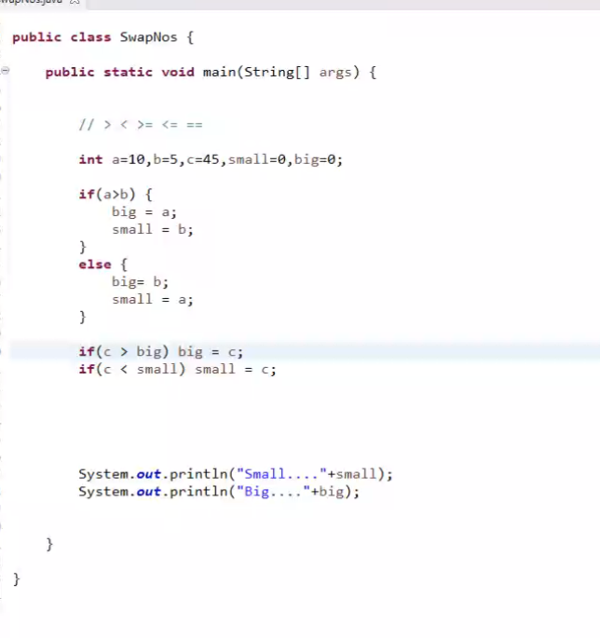

// ....comparing 2 nos

public class SwapNos {​​​​​ public static void main(String[] args) {​​​​​

int a=10,b=5,c=45,small=0,big=0;

if(a>b) {​​​​​

big = a;

small = b;

}​​​​​

else {​​​​​

big= b;

small = a;

}​​​​​

if(c > big) big = c;

if(c < small) small = c;

System.out.println("Small...."+small);

System.out.println("Big...."+big);

}​​​​​ }​​​​​

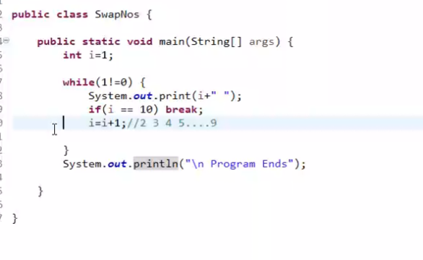

// ... infinite loop

public class SwapNos {​​​​​ public static void main(String[] args) {​​​​​

int i=1;

while(true) {​​​​​

System.out.print(i+" ");

if(i == 10) break;

i=i+1;//2 3 4 5....9

}​​​​​

System.out.println("\n Program Ends");

}​​​​​ }​​​​​

//... pre increment..

int i=1;

System.out.println(++i+"..."+(i++)+"....."+(i--)+"..."+i);//2....2.....3....2

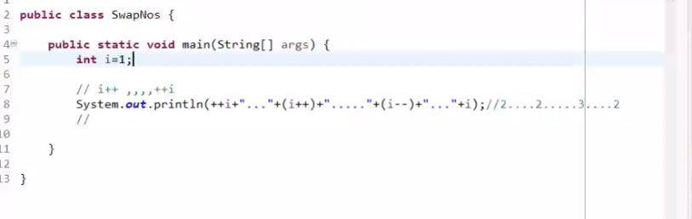

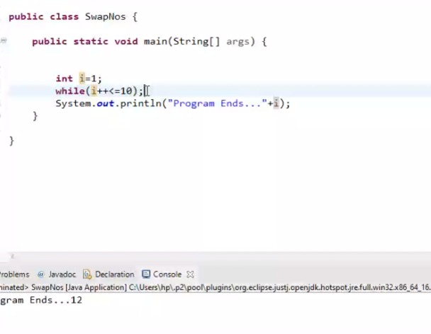

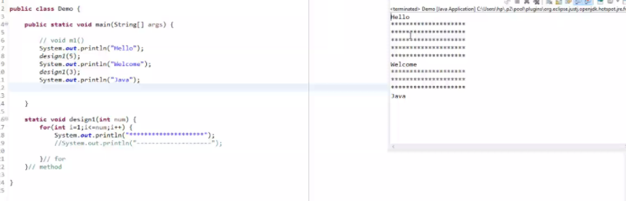

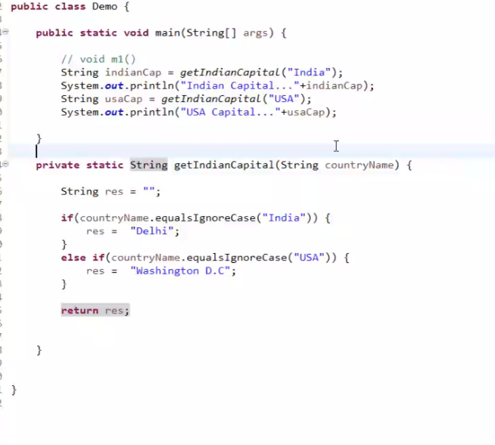

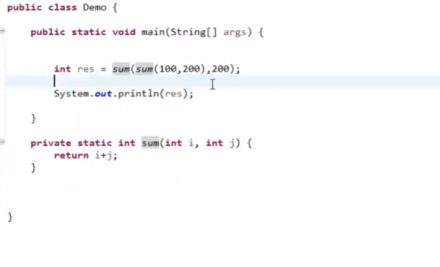
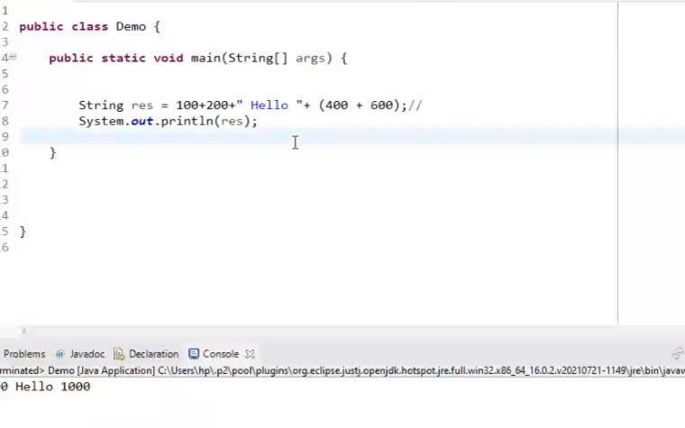

//... method.. def

public class Demo {​​​​​ public static void main(String[] args) {​​​​​

int res = sum(sum(100,200),200);

System.out.println(res);

}​​​​​ private static int sum(int i, int j) {​​​​​

return i+j;

}​​​​​

}​​​​​

Prime number:

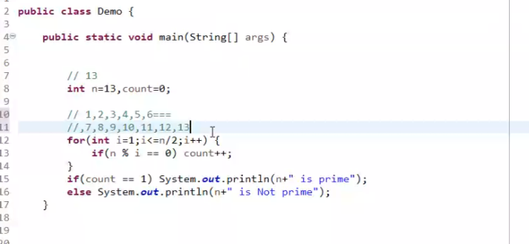
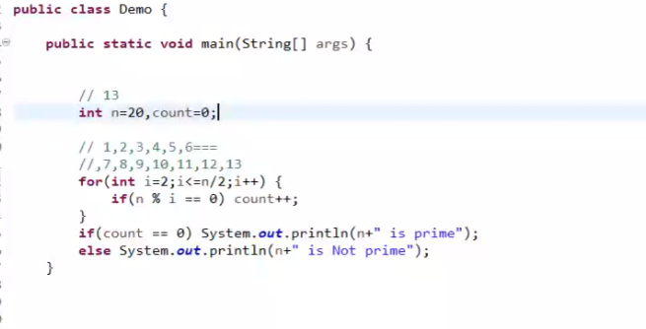
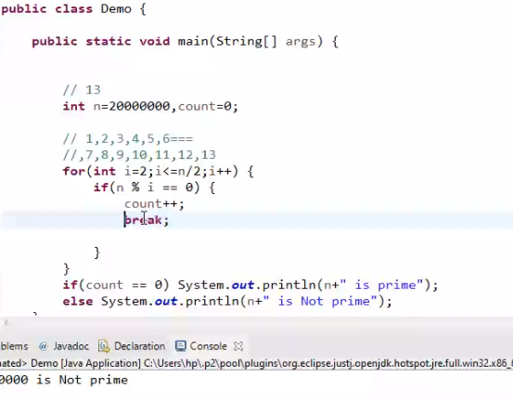
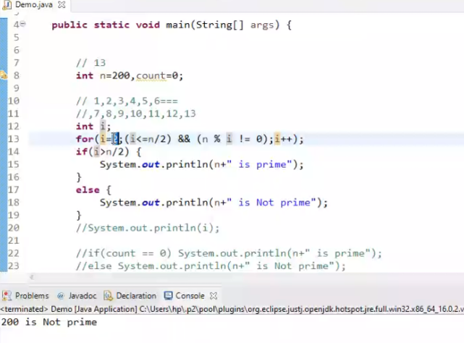
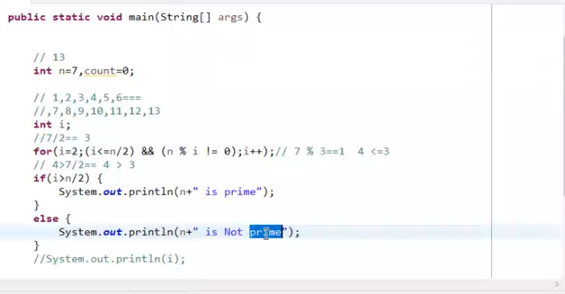

Prime number Using function:
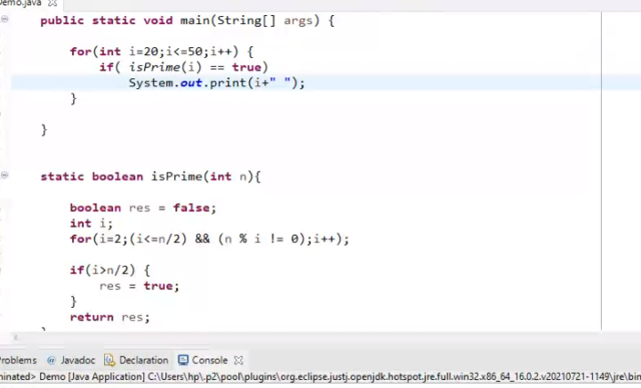
public class Demo {

public static void main(String[] args) {

for(int i=20;i<=50;i++) {
if( isPrime(i) == true)
System.out.print(i+" ");
}

}

static boolean isPrime(int n){

boolean res = false;
int i;
for(i=2;(i<=n/2) && (n % i != 0);i++);

if(i>n/2) {
res = true;
}
return res;
}

}

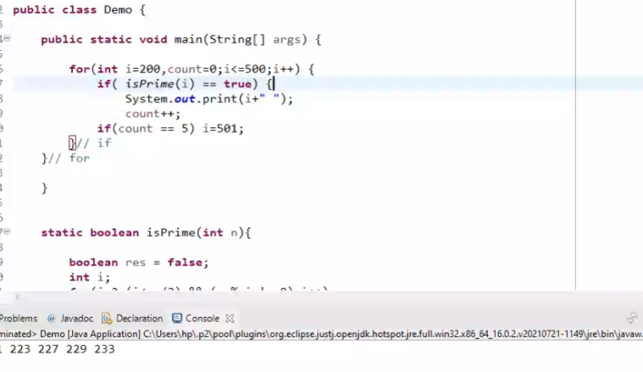
public class Main {
public static void main(String[] args) {
int count=0;
for(int i=200;i<=500;i++) {

if( isPrime(i) == true) {

count++;
if(count>5){
break;
}
System.out.print(i+" ");

}

}

}

static boolean isPrime(int n){

boolean res = false;

int i;

for(i=2;(i<=n/2) && (n % i != 0);i++);

if(i>n/2) {

res = true;

}

return res;

}

}

//biggest no among indivi nos

import java.util.Scanner; public class Demo2 {​​​​​ public static void main(String[] args) {​​​​​

int big=0,r;

Scanner scanner = new Scanner(System.in);

System.out.println("Enter number");

int n = scanner.nextInt();

while(n != 0) {​​​​​

r = n % 10;

if(r > big) {​​​​​

big = r;

if(big == 9) break;

}​​​​​

n = n/10;// 839206 83920 8392 839 83 8 0

}​​​​​

System.out.println(big+"....n value..."+n);

}​​​​​ }​​​​​

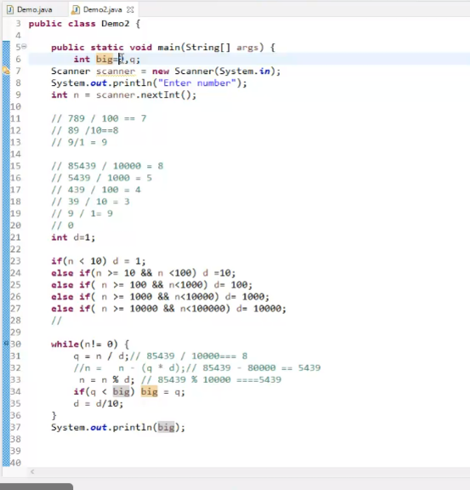

//biggest no...

[4:10 PM] tutor (Guest)
import java.util.Scanner; public class Demo2 {​​​​​ public static void main(String[] args) {​​​​​

int big=0,q;

Scanner scanner = new Scanner(System.in);

System.out.println("Enter number");

int n = scanner.nextInt();

// 789 / 100 == 7

// 89 /10==8

// 9/1 = 9

// 85439 / 10000 = 8

// 5439 / 1000 = 5

// 439 / 100 = 4

// 39 / 10 = 3

// 9 / 1= 9

// 0

int d=1;

if(n < 10) d = 1;

else if(n >= 10 && n <100) d =10;

else if( n >= 100 && n<1000) d= 100;

else if( n >= 1000 && n<10000) d= 1000;

else if( n >= 10000 && n<100000) d= 10000;

//

while(n!= 0) {​​​​​

q = n / d;// 85439 / 10000=== 8

//n = n - (q * d);// 85439 - 80000 == 5439

n = n % d; // 85439 % 10000 ====5439

if(q > big) big = q;

d = d/10;

}​​​​​

System.out.println(big);

}​​​​​ }​​​​​

//smallest no...
import java.util.Scanner; public class Demo2 {​​​​​ public static void main(String[] args) {​​​​​

int small=9,q;

Scanner scanner = new Scanner(System.in);

System.out.println("Enter number");

int n = scanner.nextInt();

// 789 / 100 == 7

// 89 /10==8

// 9/1 = 9

// 85439 / 10000 = 8

// 5439 / 1000 = 5

// 439 / 100 = 4

// 39 / 10 = 3

// 9 / 1= 9

// 0

int d=1;

if(n < 10) d = 1;

else if(n >= 10 && n <100) d =10;

else if( n >= 100 && n<1000) d= 100;

else if( n >= 1000 && n<10000) d= 1000;

else if( n >= 10000 && n<100000) d= 10000;

//

while(n!= 0) {​​​​​

q = n / d;// 85439 / 10000=== 8

//n = n - (q * d);// 85439 - 80000 == 5439

n = n % d; // 85439 % 10000 ====5439

if(q < small) small = q;

d = d/10;

}​​​​​

System.out.println(small);

}​​​​​ }​​​​​

